**NATIONAL INSTITUTE OF TECHNOLOGY, TIRUCHIRAPPALLI**

**CREATIVE WRINTING THROUGH LITERATURE**

**HSOE 11**

**DATE 5/12/2020**

**END SEMESTER EXAMINATION**

**SUBMITTED BY- SARISHMA BHANDARI**

**103117086**

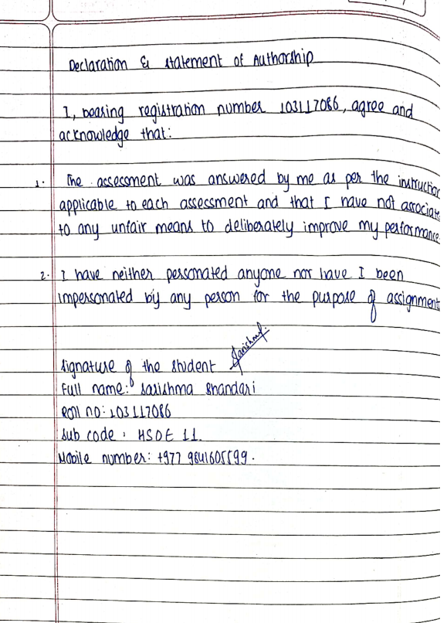

1. The first question relates to the book of your choice. We have been engaged in conversations about writing and how writers teach us all the time about crisp dialogues, vivid settings, suspenseful scenarios, inventive coinages, neologisms that find their way into the vocabulary. One way to look at our interest in books is the secret urge in each one of us that we would be able to write like the authors of those books. Our admiration is a measure of how much we want to learn writing. So, pick out at least 5 lessons in writing from the book of your choice. Identify the page number, the situation and explain the lesson in writing.

Answer:

‘The Guardians’ by John Grisham is a fabulous novel about a group who work in an organization, ‘Guardian Ministries’ spending their life to free innocent men behind bars. The writing captivates the reader with its flow of mysterious suspense. I got to learn some brilliant ideas to make my writing a better read. They are briefly pointed out below.

1. Framing a character

The writer has reinforced the appearance of Cullen Post, the protagonist, of wearing a round collar shirt like the priest.

*“Yeah, you look more like a preacher or something. Why are you wearing that collar?” (Page 44)*

Frankie who is a freelancer working for the organization is more of a calm person who interrogates with people connected to receive information that are vital for exoneration process.

*Frankie raises both hands in mock surrender and says “I come in peace. I’m just looking for information about an old case.”(Page 54)*

All along the story the characters play their role according to their predefined feature. For instance, the habit of Cullen post is looking in the rear-view mirror to see if someone is following once he hops in his car.

It takes us closer to the actual events and even let us anticipates the next step they might take.

1. Imagery

Most of the events occur inside the jail or courthouses. The description of the jail is given as;

*“I step through the detector, get cleared, and once again an innocence lawyer manages to properly enter death row without weaponry. I grab my briefcase and cell phone and follow the other guard down a sterile hallway to the walls of bars. He nods, switches click and clang, the bars slide open, and we hike down another hallway, trudging deeper into this miserable building.”(Page 2)*

The narration describes the complicated passage inside the death row and how the metal clanging is the only sound predominantly heard, describing the place as miserable as possible.

*“I’ve seen the inside of so many prisons I’m no longer shocked by their harshness. In so many awful ways they’re all the same: squat concrete buildings with no windows, rec yards filled with men in matching uniforms killing time, scowling guards reeking of contempt because I’m a trespasser there to help the lowlifes.”(Page 42-43)*

A depressing visual of prisons is communicated.

1. Neologism

The writer has used his own invention of the Prison’s name such as ‘Garvin Correctional Institute’ where Quincy has served 22 years. Also, North Carolina Correctional Institute for Women abbreviated as NCCIW. How wouldn’t the writer use the name of existing institutes that are there in the United States?

*“Quincy has spent the last years at a prison called Garvin Correctional Institute near the rural town of Peckham, about an hour north of the sprawl of Orlando.”(Page 42)*

This is because it provides a certain amount of safety in anonymity. While writing novels this should be taken care of.

1. Font

There is an event when Quincy writes a letter to Cullen Post to talk more about the trial that took place 20 years ago. Here Quincy writes to Cullen in a neat Block letters and this change the font as shown below.

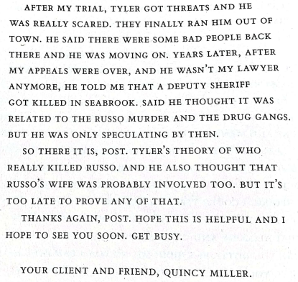

Also, a mysterious message pops in Mazy desk from anonymous and this too is shown in a different font as shown below.

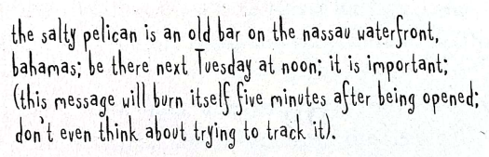

These fonts provide a shift which I think is a brilliant way to make readers more focused and to make them understand their importance.

1. Language

There is a very noticeable change in tone when Cullen or Frankie talks to different types of people for receiving information. Most of the times, the soft approach is taken for the new people whom they have never met before.

They respect everyone’s privacy and they know their limit.

It really takes a lot of effort to speak to someone who has left a horrendous past behind. They usually don’t want to talk. And pestering them isn’t the brightest choice.

Knowing our character role is very important while writing so that accordingly we can use the required tone while they are speaking to someone else.

2. Prepare an interactive map of your book by plotting the narrative through its many episodes or scenes by way of guiding a reader who wants to know what the book is all about.



Meet Cullen Post, Vicky Gourley, Mazy Ruffin and Francois Tatum (Frankie), the four pillars of ‘Guardian Ministries’ founded 12 years ago. Their work, to free the innocent men locked up for someone else’s crime.



They have freed eight people till now, Frankie being their first exonerre. It’s the freedom they have helped innocent men achieve, keeps them moving.



They are working with Duke Russell, a 38 years old white man convicted of raping and murdering Emily Broone and Quincy Miller who is serving 8 years in Gavin Correctional Institute for murdering Keith Russo, a renowned lawyer in Seabrook. Both of them are not guilty and the guardians are working hard every day to gather sufficient evidences to help them breathe free air.



For Duke, the evidence for conviction was the seven pubic hairs found in Emily Broone’s body without any DNA testing.



But to prove Duke as an innocent, Cullen has to get hold of the pubic hairs and do a DNA testing of the real culprit. Often it involves a dirty work of stealing. But post doesn’t want to skip just because it is wrong to steal. Let it be wrong if it saves a life of a man, thinks post.



The DNA report matches with the true murderer, Mark Carter. Judge Marlow doesn’t waste much time to free Duke. Though the Prosecutor, Chad Falwright, tries many interventions to not let this happen, he doesn’t succeed. Finally Duke becomes the ninth member, the Guardians have successfully exonerated.



With Quincy however, the dirty truth arrives in every turn. We have drug dealers, the local sheriff involved and even the jail inmates who have tried killing Quincy in jail. Quincy had to stay in the ICU for many days.



This horrific event didn’t leave any of the Guardians to stop working; instead they hired an FBI agent and started digging about the assault in jail that nearly killed Miller.



The case went skyrocketing, many names were disclosed and finally the culprits who murdered Keith Russo and Kenny Taft were put behind bars.



Meanwhile Miller recovered and started living as a free man; another story to motivate ‘The Guardians’ to continue their work.

3. The premise of this question is that, all the books –past, present and future-constitute the matrix of the popular imagination. They are written and read for the reason that there are popular elements that readers romance. The bestseller feeds the reader those elements. An aggregate of all these elements constitute the Martix. As an illustration, while Mumbai is the geographical Matrix, people want to go there for different reasons: as tourists, as professionals, as beggars, as cab drivers, as entrepreneurs, as bar dancers, as policemen, even as robbers and gangsters. Now, it is possible to see the Matrix of Mumbai as constituted by the many reasons that form the elements. Identify at least 5 elements in the matrix of popular fiction/imagination using your book as the microcosm of the Matirx.

Answer:

1. Racial Injustice in America

America is not new to racial injustice. The anti-black violence has threatened the black civilians across the country for decades. News about Black Americans being killed or convicted for a false crime is heard often. This is depicted perfectly in the novel as;

“*In White America, prisons are good places where bad men pay for their crimes. In Black America they are too often used as warehouses to keep minorities off the streets*.”

1. The Last Meal

In some parts of Asia and America the ritual of ‘The Last Meal’ is still followed in Prisons. It is a ritual of giving desired foods to the person before execution. Usually alcohol is restricted. The book portrays the dramatic scene of Duke Russell in a death row with his last meal in the beginning of the novel that gives us the idea of how awful this ritual is.

*“At execution time, every death state has its own silly rituals, all designed to create as much drama as possible. Here, they allow full-contact visits with close family members in a large visitation room. At 10:00 p.m., they move the condemned man to the Death Room, which is next door to the Death Chamber where he’ll be killed. A chaplain and a lawyer are permitted to sit with him, but no one else. His Last meal is served around 10:30, and he can order whatever he wants, except for alcohol”*

1. Miscarriage of Justice

It is estimated that 2.3-5 % of all US prisoners are innocent. And in our book we know how these innocent people had to be confined for decades till their freedom was announced. One of the judges, Judge Marlowe, who helped Duke Russell to be free, says a remarkable statement about miscarriage of justice in the system.

*“Mr. Russell, your convictions for rape and capital murder are hereby vacated and dismissed. Forever, and they cannot be bought back. I was not involved in your trial, obviously, but I do consider it a privilege to be involved here today with your exoneration. A grave miscarriage of justice has occurred and you have paid a dear price. You were wrongfully convicted by the State of Alabama and incarcerated for a decade. Years that can never be replaced. On behalf of the State, I say that I’m sorry, and I realize my apology does not even begin to heal your wounds. However, it is my hope that one day soon you will remember the apology and take some small measure of comfort in it. I wish you a long happy life with this nightmare behind you. Mr. Russell, you are free to go.”*

1. Wiser/Crazier Solitary Confinement

It is often known how the solitary confinement drives people crazy but there are some who use this time to read and become wiser. There are instances of both of them in the novel.

*“He was a party boy and hell-raiser in his younger days, but after nine years in solitary he has settled down considerably.”*

1. Injustice in judiciary

The bad trial of a crime scene may lead to a conviction of an innocent man. Mostly in the United States this leads to an execution while the guilty roam freely as in the case of Duke Russell.

*“The fact that he has spent twenty-two years inside a prison where he is presumably safe from the outside, and is still worried, is revealing. Keith Russo was murdered for a reason. Someone other than Quincy Miller planned the killing, pulled it off with precision, then got away. What followed was a through framing that involved several conspirators.”*

4. Design an exercise for the Creative Writing Class. Your answer must follow the given template strictly: 1. State the objective of the exercise. 2. Provide clear instructions to the class so that they are motivated toperform. 3. Provide a step-by-step manual as to how the exercise must be conducted. 4. Write down the expected outcomes clearly.

Objective:

Teach aspiring story writers to be focused on their story and have a clear beginning and ending.

Instructions:

* Ask the students to pick up their favourite quote or a proverb.
* On the basis of the chosen quote, ask them to write a story that is able to depict its meaning.
* The exercise is to be given at the beginning of the semester so that the students can learn and use the techniques taught in class and to weave a better story.

Description:

For instance, the famous quote of Einstein;

“Everyone is a genius. But if you judge a fish by its ability to climb a tree, it will live its whole life believing that it is stupid.”

can be used to invent a story that revolves around the fact that everybody is unique, blessed with individual talent and it is a waste of both energy and time to compare ourselves with other people.

Probable Outcomes:

* The students will be able to draft a story with a proper beginning and ending.
* The students will be able to use the new writing skills taught in class.
* It gives students motivation to write more stories.